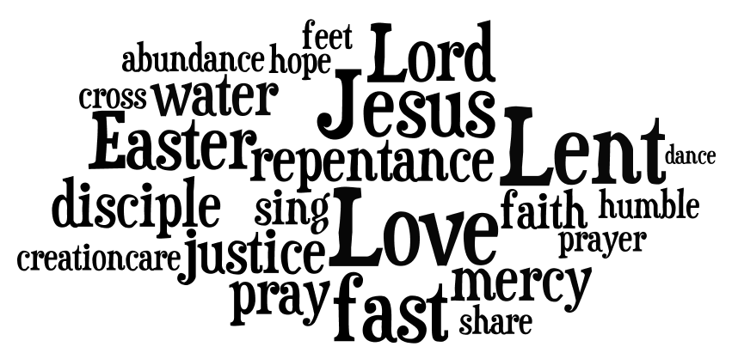

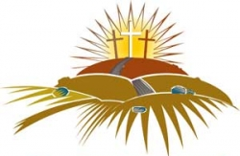

What am I facing towards, that means I’m ending up with my back to God?

A Resource for Individuals and Small Groups for Lent 2012

